QERaman Instllation

<https://github.com/nguyen-group/QERaman>

1. We install compiler and library for making QE

sudo apt update

sudo apt install git wget build-essential

sudo apt install g++ gfortran liblapack-dev

sudo apt install libfftw3-dev libopenmpi-dev

1. We install quantum espresso from the source files at ~/opt

cd

mkdir opt

cd opt

git clone https://github.com/QEF/q-e.git

./configure

make all

1. We install QERaman in ~/opt/q-e

cd ~/opt/q-e

git clone <https://github.com/nguyen-group/QERaman.git>

cd QERaman/src

make all

1. Change PATH in ~/.bashrc

export PATH="$HOME/.local/bin:$HOME/opt/q-e/bin:$HOME/opt/q-e/QERaman/bin:$PATH"

update .bashrc

% source ~/.bashrc

1. Go to example of MoS2

cd ~/opt/q-e/QERaman/example/mos2

emacs run.sh

mpirun -np 48　should be changed to mpirun -np 4 or -np 8

emacs scf.in

change k point mesh from 48x48x1 to 12x12x1

https://interactivephonon.materialscloud.io/

./run.sh &

cp reference/\*.ipynb .

cp reference/sci.mplstyle .

jupyter-lab plot-raman-spectra.ipynb

jupyter-lab plot-raman-polar.ipynbj

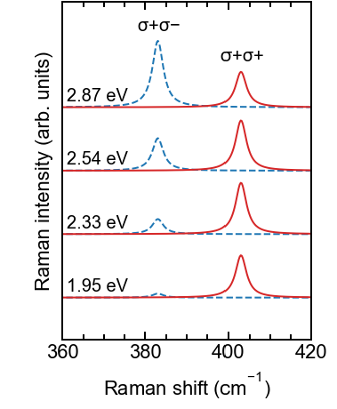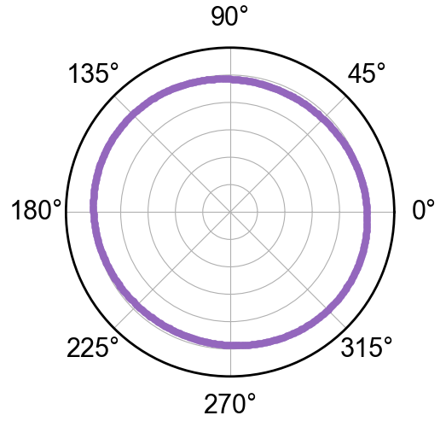

Change R1 to R2 or R3

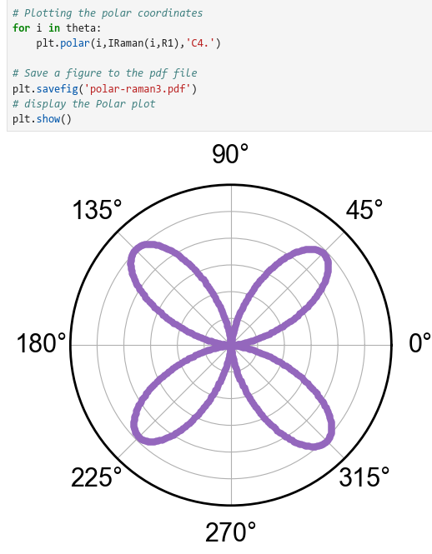

%

% 10. Calculate dielectric function

%

cd QE-SSP/mos2/optic/

nano run.sh (Change to "-np 8" if CPU has a power.)

(time ./run.sh) 2> time.out & (Run the job. It takes 18 mins)

top

jupyter-lab eps.ipynb & (Plot dielectric function)

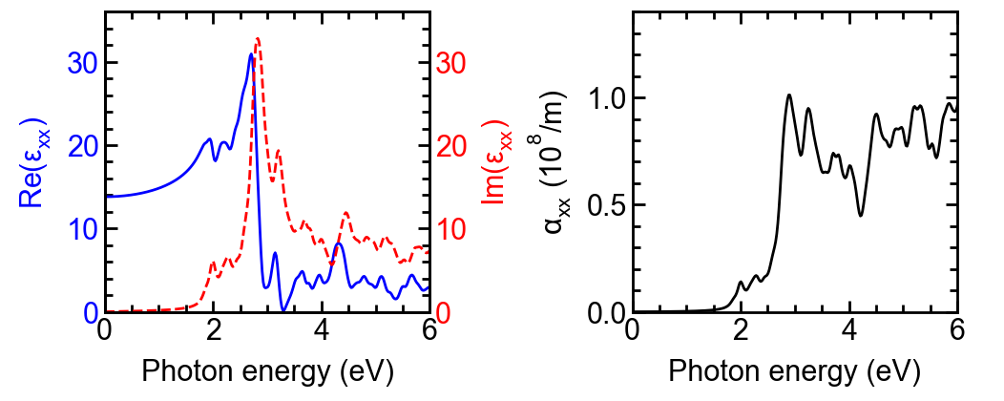

Errata of Book: <https://github.com/nguyen-group/QE-SSP/discussions/3>

Visualize phonon vibration by phonon calculation.

<https://interactivephonon.materialscloud.io/>

Another choice is using dynmat.axsf by xcrysden

HOW to make QE input files by yourself.

Get cif file from aflow. You can even find QE input file there.

Make scf.in from cif file

<https://www.materialscloud.org/work/tools/qeinputgenerator>

we need to download SSSP pseudopotential.

https://www.materialscloud.org/discover/sssp/table/efficiency